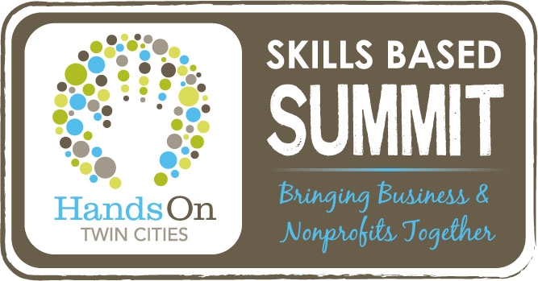
The Skills Based Summit will bring together our corporate partners with nonprofits, schools, and faith-based organizations for a day filled with learning and sharing best practices. This is an incredible opportunity for ANY nonprofit professional, organizational leader, board member, or volunteer!
2012 Skills Based Summit Registration Form
(one form per person)

- Friday, November 16, 2012, 8:00AM-4:30PM, Mall of America 4th Floor
- General Mills, Cummins, Thomson Reuters, Deloitte, 3M, Medtronic, and UnitedHealth Group, will be offering group workshops
- You will be able to attend up to six rounds of workshops
- Consultation sessions will occur concurrently for more specific requests. Issues to be discussed during the consultations will be based upon the major presentation/workshop topics. Sign up when you check in at the Mall of America

$25* is our EARLY BIRD SPECIAL ending on October 16th.
After that, registration will be $50 until all spots are filled.
For those organizations that wish to bring multiple people (3 or more) a limited amount of scholarship assistance may be available. If you’re interested, please contact Dave at 612-379-4900 ext 10.

Contact Information
Name:
Address:

Phone:
E-mail:
Organization:
Role/Title:

Payment Options
- Check Enclosed
- Credit Card
Visa/MasterCard, American Express, Discover
Card Number:
Expiration:
CVV Code:
Zip Code on Billing Statement:

Please return this form with payment to HOTC:
2021 E. Hennepin Ave, Suite 420, Minneapolis, MN 55413
Fax: 612-379-3104
info@handsontwincities.org

Signature:

To help us determine which topics would benefit you the most, please indicate which workshops and/or consultations you would be interested in attending.
The CIRCLES indicate workshop sessions, and the SQUARES indicate consultation sessions. Please check all that apply below:
- General Mills – Social Media Strategies
- Cummins – Customer Support Excellence
- Thomson Reuters – Technology/Web Design
- Deloitte – Project Management Strategies
- 3M – Finance
- Legal Issues
- Leadership Development

Discount on 2013 HOTC Affiliation fee – one discount per organization (not to be combined with early bird renewal for current affiliates) OR a Free HOTC workshop (up to a $60 value).
*EXTRA BENEFIT!
As a benefit for attending the Summit, you will receive a coupon that day, which you may use for one of the
following:

- Ever wonder how a corporation markets its product to its audiences? Or how it utilizes social media to reach new customers?
- Do you need tips on making your organization run more smoothly?
- Are you interested in hearing ideas from the corporate perspective?

Then join us for the chance to learn valuable skills while networking with professionals in your area!

We realize that many of our nonprofit partners utilize practices common to the corporate industry when fulfilling their day-to-day operational needs. That is why we are hosting the Summit to bring together our corporate partners with nonprofits, schools, and faith-based organizations for a day of learning and sharing best practices. Through group workshops and consultations, corporate experts will be offering their knowledge and expertise on a variety of topics. We welcome every volunteer manager, staff member, board member, organizational leader, and volunteer/intern to join us for this unique opportunity. Feel free to spread the word to anyone within your network!

General Mills, 3M, Thomson Reuters, Medtronic, UnitedHealth Group, Deloitte, and Cummins will be providing workshops on topics ranging from marketing, social media, customer support, technology, finance, legal issues, and more. Umbrella organizations such as the Charities Review Council, GiveMN, and the Minnesota Council of Nonprofits will also be present to share their advice.

Hurry in and register today!

